**What is a Web Component?**

Wondering what a web component is? It's actually three different technologies that work together to provide custom elements in your web applications. They are encapsulated to ensure they play nicely with other elements with no code collisions. A web component includes:

* Custom Element, or a JavaScript that extends the HTMLElement using templates and custom logic.
* Shadow DOM, which allows you to segment your CSS and JavaScript from your main document DOM, so it can be styled and scripted separately.
* HTML templates that aren't rendered until called upon and can be reused multiple times for the web component.

Web components are simple to read and write in the main document DOM:

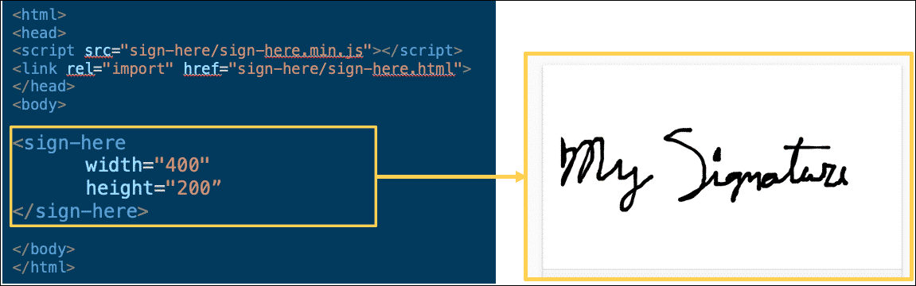

Web components make the UI load much **faster** and **lighter** since they don't have to load extra Javascript libraries. They’re easy to **reuse** partly because the custom tags are easy to read and write. Finally, every major browser supports them.

**Industries Web Components and the SDK**

Using this standard, Industries has developed a library of web components to make developing digital commerce applications faster and easier. By using Industries Digital Commerce web components and the Digital Commerce SDK together, you will be able to achieve a wealth of functionality and extensibility that is reusable, safe, and maintainable.

For example, you can put custom JavaScript functions in a web component and use the SDK to do things like deleting products from the cart.  
  
This is a diagram of the relationship between an SDK and web components:

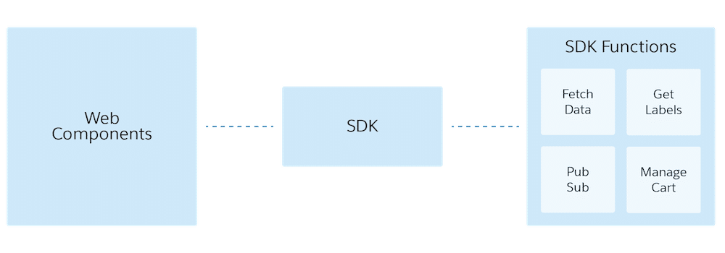

**What's the Difference Between a Lightning Web Component and a Web Component?**

In addition to Industries Digital Commerce web components, Industries is also developing a parallel library of Digital Commerce Lightning web components.

**Lightning web components** are web components that run inside Salesforce. They implement the web component standard but use select Salesforce libraries and packaging conventions. **Lightning** refers to a Salesforce framework that uses Javascript in the browser rather than server-side code to render the UI.

You can use either the Digital Commerce Lightning web components or the Digital Commerce web components with the Digital Commerce SDK. The only difference is that when you are using the Digital Commerce Lightning web components, you are developing an application on the Salesforce platform, perhaps on a Community or in an OmniScript, and when you are using the Digital Commerce web components, you are developing an off-platform application that can optionally deploy the Digital Commerce Tier for elastic scalability.

**The Digital Commerce User Experience**

As we discussed in the SDK topic, there are four distinct phases of a digital commerce experience. Digital Commerce web components support the same four phases, which are **Browse**, **Configure**, **Cart**, and **Checkout**.

**Browse Phase**First, users browse the available offers in the catalog. This is the **Browse** phase.  
  
The Digital Commerce solution supports this phase by giving you home page and catalog web components to retrieve and display catalog offers and individual offer details.

**Configure Phase**Second, users may select an offer and configure it, which may change the pricing and availability, we'll call this the **Configure** phase.  
  
Digital Commerce Web Components support this phase by offering ways to render offer pricing, colors, other attributes, and media. In this phase, the virtual "basket" is not shown to the user.

**Cart Phase**Third, users may add the configured offer to their cart (a container of saved line items), and we'll call this the **Cart** phase. This phase may be skipped if the user directly orders the offer ("buy now") from the offer page. The web components here allow the user these functionalities as well as render the cart (virtual "basket") itself.

**Checkout Phase**Finally, when the user is ready to review their order, enter in or retrieve shipping, billing, and payment information, and finally submit their cart so that it may become an order, this is the **Checkout** phase.  
  
Digital Commerce Web Components support this phase by showing the user the total of the cart and allowing them to proceed to checkout (i.e., initialize the checkout process by creating an order from the cart's contents).

**The Industries Digital Commerce Sample App**

The Industries Digital Commerce sample app is available to Industries customers and partners as a working reference to learn more about a possible Digital Commerce solution. It is not intended to be deployed to a production environment.

To access the sample app, visit the [Salesforce Industries Process Library](https://success.vlocity.com/s/process-library-category?Id=aBQo0000000PAsRGAW) and select Digital Commerce under Filter by Category. It is listed as "Explore & Checkout for Off-Platform Usage".

**Getting Started with Digital Commerce Web Components**

Digital Commerce web components were developed using a Google library called LitElement, which is a simple base class for creating fast, lightweight web components. Industries' web components are encapsulated. You can develop your applications using any library and any tool that supports Web Standards. There are no dependencies on Google Polymer, however, and because of its foundation on LitElement, Digital Commerce web components provide full support for a shadow DOM.

You can use Industries Digital Commerce web components to develop Single-Page-Applications (SPAs) and also non-SPA applications. Each web component comes with defined methods to retrieve data and a Newport-style template to render data.

Need to go through this doc https://docs.vlocity.com/devdocs/wc/index.html